Data from denormalized table:

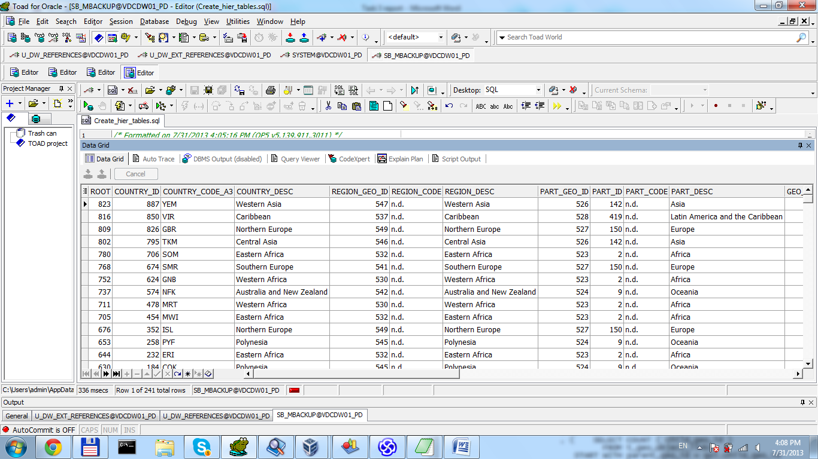

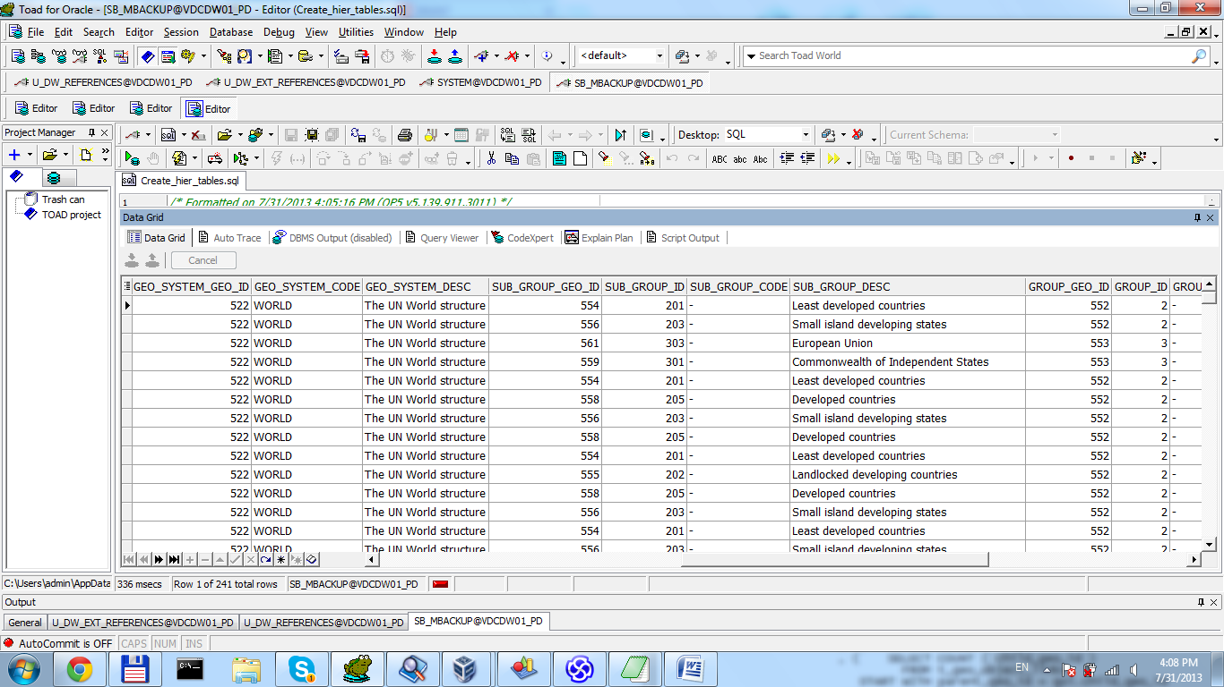

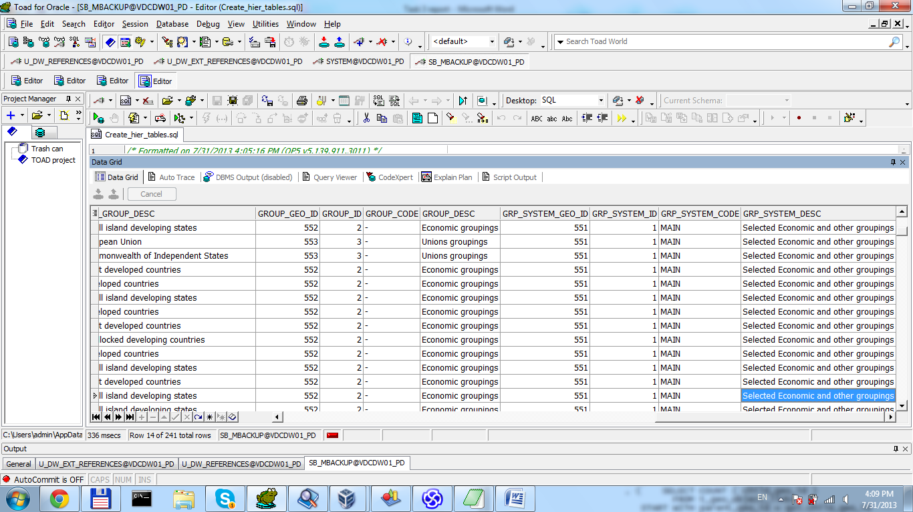

Query for create:

*/* Formatted on 7/31/2013 4:05:16 PM (QP5 v5.139.911.3011) */*

CREATE TABLE denormalized_geo

AS

SELECT root

, country_id

, country_code_a3

, region_desc AS country_desc

*--region*

, NVL ( l_3, -99 ) AS region_geo_id

, NVL ( region_code, 'n.d.' ) AS region_code

, NVL ( region_desc, 'n.d.' ) AS region_desc

*-- part*

, NVL ( l_2, -99 ) AS part_geo_id

, NVL ( part_id, -99 ) AS part_id

, NVL ( part_code, 'n.d.' ) AS part_code

, NVL ( part_desc, 'n.d.' ) AS part_desc

*-- geo_systems*

, NVL ( l_1, -99 ) AS geo_system_geo_id

, NVL ( geo_system_code, 'n.d.' ) AS geo_system_code

, NVL ( geo_system_desc, 'n.d.' ) AS geo_system_desc

*-- group_items*

, NVL ( l_6, -99 ) AS sub_group_geo_id

, NVL ( sub_group_id, -99 ) AS sub_group_id

, NVL ( sub_group_code, 'n.d.' ) AS sub_group_code

, NVL ( sub_group_desc, 'n.d.' ) AS sub_group_desc

*-- groups*

, NVL ( l_5, -99 ) AS group_geo_id

, NVL ( GROUP_ID, -99 ) AS GROUP_ID

, NVL ( group_code, 'n.d.' ) AS group_code

, NVL ( group_desc, 'n.d.' ) AS group_desc

*-- group system*

, NVL ( l_4, -99 ) AS grp_system_geo_id

, NVL ( grp_system_id, -99 ) AS grp_system_id

, NVL ( grp_system_code, 'n.d.' ) AS grp_system_code

, NVL ( grp_system_desc, 'n.d.' ) AS grp_system_desc

FROM ( ( SELECT *

FROM ( SELECT parent_geo_id AS geo_id

, CONNECT_BY_ROOT child_geo_id AS root

, link_type_id

FROM u_dw_references.t_geo_object_links

START WITH child_geo_id IN (SELECT DISTINCT geo_id

FROM u_dw_references.lc_countries)

CONNECT BY PRIOR parent_geo_id = child_geo_id) PIVOT (MAX ( geo_id )

FOR link_type_id

IN (1 AS l_1

, 2 AS l_2

, 3 AS l_3

, 4 AS l_4

, 5 AS l_5

, 6 AS l_6))

LEFT JOIN u_dw_references.lc_countries lc

ON ( root = lc.geo_id )

LEFT JOIN u_dw_references.lc_geo_regions reg

ON ( l_3 = reg.geo_id )

LEFT JOIN u_dw_references.lc_geo_parts par

ON ( l_2 = par.geo_id )

LEFT JOIN u_dw_references.lc_geo_systems sys

ON ( l_1 = sys.geo_id )

LEFT JOIN (SELECT *

FROM u_dw_references.cu_cntr_group_systems

UNION

SELECT geo_id * 2

, grp_system_id

, grp_system_code

, grp_system_desc

, localization_id

FROM u_dw_references.cu_cntr_group_systems) gr_sys

ON ( l_4 = gr_sys.geo_id )

LEFT JOIN u_dw_references.cu_cntr_groups cu

ON ( l_5 = cu.geo_id )

LEFT JOIN u_dw_references.cu_cntr_sub_groups sub

ON ( l_6 = sub.geo_id ) ));

Create path_table:

CREATE TABLE path_table

AS

SELECT SYS_CONNECT_BY_PATH ( child_geo_id

, '\' )

geo_path

, child_geo_id

, LEVEL AS "level"

, CONNECT_BY_ROOT child_geo_id AS root

, CASE

WHEN CONNECT_BY_ISLEAF = 1 THEN 'LEAF'

WHEN LEVEL = 1 THEN 'ROOT'

ELSE 'BRANCH'

END

AS status

, DECODE ( CONNECT_BY_ISLEAF

, 1, NULL

, ( SELECT COUNT ( child_geo_id )

FROM u_dw_references.t_geo_object_links

START WITH parent_geo_id = mb.child_geo_id

CONNECT BY PRIOR child_geo_id = parent_geo_id ) )

child_count

FROM (SELECT *

FROM u_dw_references.t_geo_object_links

UNION

SELECT NULL

, geo_id

, NULL

FROM u_dw_references.lc_cntr_group_systems) mb

START WITH parent_geo_id IS NULL

CONNECT BY parent_geo_id = PRIOR child_geo_id;

Data:

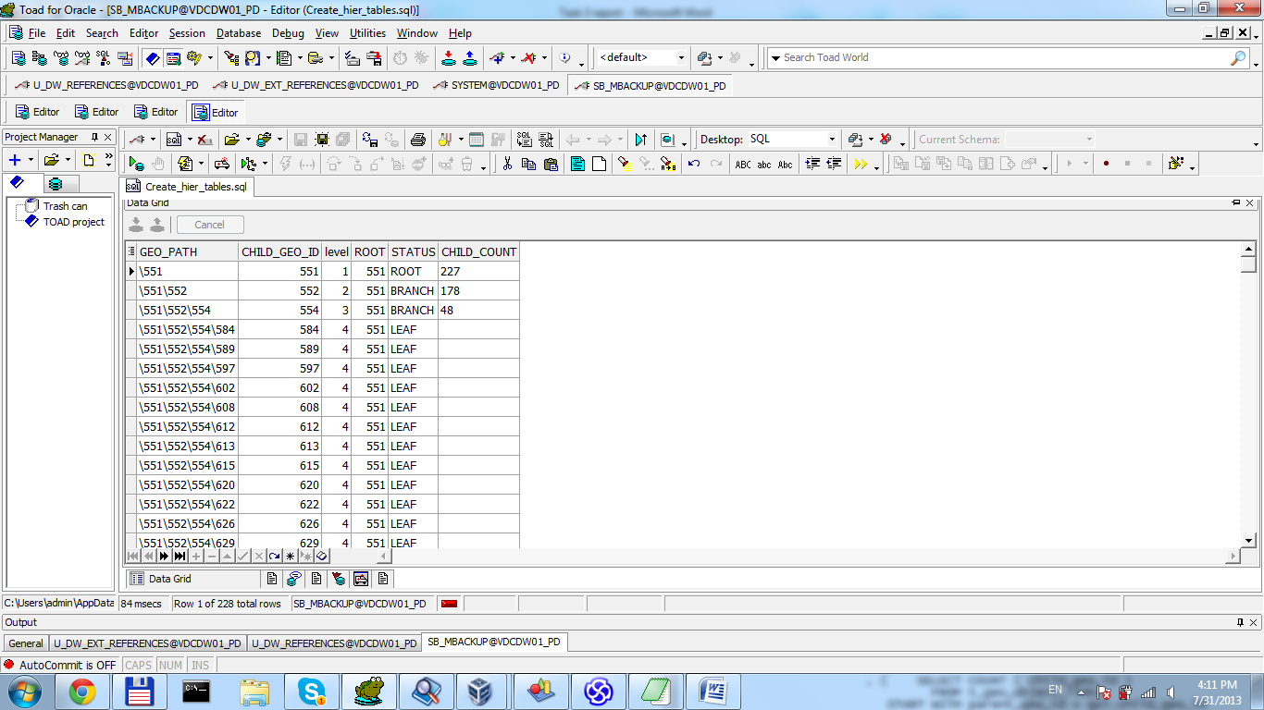

Script create user user

create tablespace SB_MBackUp datafile 'DATA1.dbf' size 5 M LOGGING

create user SB_MBackUp identified by pass default tablespace SB_MBackUp quota unlimited on SB_MBackUp

grant select any table to SB_MBackUp

grant connect, resource to SB_MBackUp

Task 2

Analyze product hierarchy:

Query:

*/* Formatted on 7/31/2013 6:35:31 PM (QP5 v5.139.911.3011) */*

CREATE TABLE prod_links

AS

SELECT prod_id

, prod_category_id

FROM ext_products;

SELECT LPAD ( ' '

, LEVEL * 4 )

|| prod_name

prod_heirarchy

, DECODE ( CONNECT_BY_ISLEAF

, 1, '--'

, ( SELECT COUNT ( prod_id )

FROM prod_links

START WITH prod_category_id = co.prod_id

CONNECT BY prod_category_id = PRIOR prod_id ) )

count_products_titles

, prod_desc product_description

, income_coef

FROM (SELECT *

FROM (SELECT fir.prod_id

, fir.prod_category_id

, sec.prod_name

, sec.prod_desc

, sec.income_coef

FROM (SELECT *

FROM prod_links

UNION

SELECT prod_category_id

, NULL

FROM prod_links) fir

JOIN

(SELECT prod_id

, prod_name

, prod_desc

, income_coef

FROM ext_products

UNION

SELECT prod_category_id

, prod_category

, NULL

, NULL

FROM ext_prod_categories) sec

ON fir.prod_id = sec.prod_id)) co

WHERE LEVEL = 2

OR prod_id > 100

START WITH prod_id = prod_id

CONNECT BY prod_category_id = PRIOR prod_id;

Dataset:

